Search Page

Definition
# Source: AI Source: Provided by: [Data Path: Persons Table -> ID Column: 1, Name_En Column: Motasem Essam] -> From: [Chatgpt (GPT‑5 Mini)] on [2/12/2026]
A Search Page is a web page that allows users to look for specific content, products, or information on a website using keywords or filters.

Simple Definition
# Source: AI Source: Provided by: [Data Path: Persons Table -> ID Column: 1, Name_En Column: Motasem Essam] -> From: [Chatgpt (GPT‑5 Mini)] on [2/12/2026]
Search Page = a page where users can type a query to find what they want on the website.

What a Search Page Usually Includes
# Source: AI Source: Provided by: [Data Path: Persons Table -> ID Column: 1, Name_En Column: Motasem Essam] -> From: [Chatgpt (GPT‑5 Mini)] on [2/12/2026]
- Search bar / field – where users enter keywords
- Search button – to start the search
- Results list – links to pages, products, articles, or items matching the query
- Filters / sorting options (optional) – narrow down results by category, date, price, etc.
- No results message – shows suggestions if nothing matches

Purpose of a Search Page
# Source: AI Source: Provided by: [Data Path: Persons Table -> ID Column: 1, Name_En Column: Motasem Essam] -> From: [Chatgpt (GPT‑5 Mini)] on [2/12/2026]
- Help users find information quickly
- Improve website usability and navigation
- Reduce time spent browsing through multiple pages
- Increase chances that users interact with content or products

Examples
# Source: AI Source: Provided by: [Data Path: Persons Table -> ID Column: 1, Name_En Column: Motasem Essam] -> From: [Chatgpt (GPT‑5 Mini)] on [2/12/2026]
- E-commerce website → search for a specific product like “red shoes”
- Blog → search for articles on “web development”
- Educational site → search for courses or tutorials
- Social media → search for users, hashtags, or posts

Difference Between Search Page and Home Page
# Source: AI Source: Provided by: [Data Path: Persons Table -> ID Column: 1, Name_En Column: Motasem Essam] -> From: [Chatgpt (GPT‑5 Mini)] on [2/12/2026]
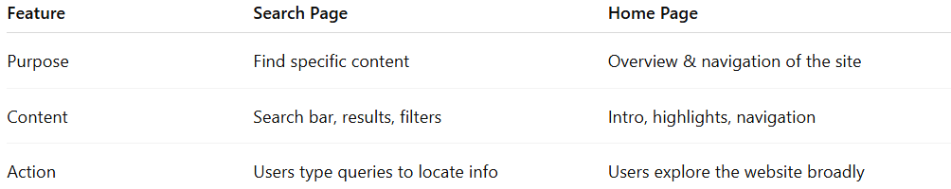
Feature | Search Page | Home Page
Purpose | Find specific content | Overview & navigation of the site
Content | Search bar, results, filters | Intro, highlights, navigation
Action | Users type queries to locate info | Users explore the website broadly

